


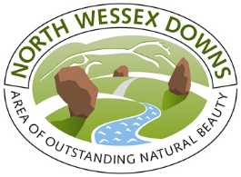

Cholsey Parish Council Community Consultation

FOREWORD
by Dr Stephen Head  As a long term Cholsey resident I am delighted that the Mend the Gap programme can be active in our area. Cholsey is a classic south Oxfordshire parish “with its feet in the clay and its head in the chalk” and we have a rich mix of habitats and species. In a time of severe wildlife decline and prospective climate change, the scheme provides a wonderful opportunity to take stock of what we have, to plan to maintain and improve it, and undertake new habitat creation projects fit for the future. | 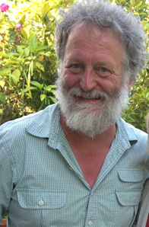  Dr Stephen Head

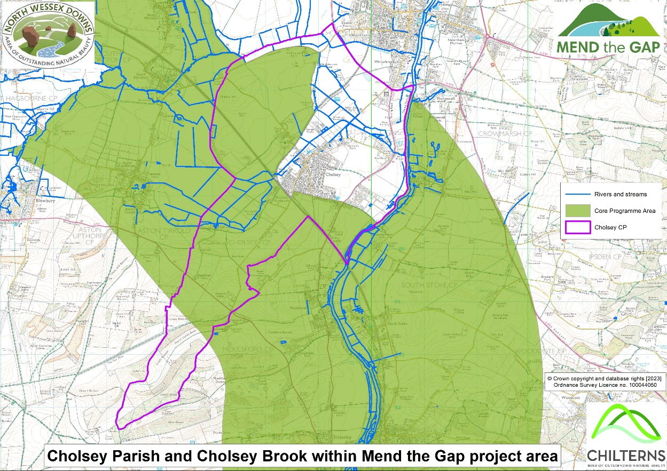

Consultation structure

The consultation was held at the Cholsey Pavilion on 12th October 2023 and promoted locally using email, social media and word of mouth.

The following document summarises the feedback that we had from the 31 local people that attended, this is not meant to be a formal delivery document but a summary of the points of view of members of the local community.

Outline of the event held
Meeting Date 12th October 2023

Meeting Time 19.00-21.00

Meeting Location Cholsey Pavilion

Audience People from the local community

AIM: To inform and consult the communities of Cholsey and neighbouring parishes and put a proposal together for the Mend the Gap Programme

AGENDA

7.20 Welcome from Vicky Beardall-Richards
7.25 Introduction to Mend the Gap (10 mins) Ruth Staples-Rolfe Mend the Gap programme manager
7.35 Introduction to the consultation (5mins)
Refreshments
8.35 Conclusion led by Dr Steve Head
Sum up what we have learnt from the consultation and what our next steps might be
8.50 Closing comment Vicky Beardall-Richards
9pm Finish

Where are sites of wildlife interest and why?
The following table summarises the feedback that we had from the 31 local people that attended, this is not meant to be a formal delivery document but a summary of the points of view of members of the local community.

 | Site of interest | Reason for interest
 | Moulseford Viaduct | Otters sighted near here
 | Cholsey Marsh Nature Reserve | Desmoulin whirl snail and birds
 | Westfield Road and surrounding fields | Hares
 | Brick sheds | Barn owls
 | Chalk streams connecting villages (Amwell)  Wetland mosaics | Voles, weasels, brown trout, and signal crayfish
 | Lollington Hill | Birds, butterflies
 | Cholsey Churchyard | Butterflies
 | Aston reedbeds | Over 50 years of harvest mice records
 | The Lees (the long ditch) conservation area | Water vole, lapwing,
 | Blewberry hill | chalk grassland
 | South Moreton | Lapwing on grassland
 | Manor farm | Barn owls
 | Bow bridge | Woodland
 | Caps’ lane to the Thames River | Rewilding meadow, rich with insects
 | Thames river | Kingfisher, perch, Thames wood
 | River Meadow opposite Caps Lane | Exceptional grassland flora and butterflies – I think this the same place as two above?

Where are there other sites of interest and why?
The following table summarises the feedback that we had from the 31 local people that attended, this is not meant to be a formal delivery document but a summary of the points of view of members of the local community.

 | Site of interest | Why
 | Thames and National trail | National trails with access to wider areas  WW2 pillboxes
 | Ridgeway National trail | National trails with access to wider areas  Access to Grimms ditch
 | Lollingdon | Poets John Masefold  Edward Thomas
 | Recreation field | Sports
 | Cholsey hill | Never enclosed, needs interpretation
 | Cholsey Long barn | Longest of its type
 | Monastical Fish ponds at the school | Medieval importance to use of the water for food and beer
 | Cricket club | Sports
 | Fairmile hospital | Former psychiatric hospital, developed into housing and community space.
 | Cholsey Church | Historic saxon origin, Agatha Christie grave

Where are the wet places that might create wet habitats?
The following table summarises the feedback that we had from the 31 local people that attended, this is not meant to be a formal delivery document but a summary of the points of view of members of the local community.

 | Site of interest | why
 | Manor Farm | Two areas that might be suitable for ponds
 | Thames flood plain (upstream from Ferry Lane) | To reopen the scrapes that were dug in the 1990’s but lost during the building of Cholsey meadows (particularly important to many of those attending)
 | Amwell spring | Chalk stream currently used for brewing local beer
 | Freshwater mosaic of streams | Nesting birds
 | Old monastery fishponds
 | Aston Upthorpe – area by the tunnel needs reviving (writing suggests Bliccs Lane??)
 | Upthorpe farm drainage | Harvest mice and reed buntings and sedge warblers
 | The Lees and the farmland around that area | Create water ponds for waders (very popular with those attending)
 | North Moreton | Land North of street floods
 | Corridor from Cholsey to the Astons | Wildlife corridor

Who might we need to get involved (landowners)
The following table summarises the feedback that we had from the 31 local people that attended, this is not meant to be a formal delivery document but a summary of the points of view of members of the local community.
Any additional feedback from those unable to attend is also welcome.

 | Landowner | To possibly discuss
 | Greenlands farm, Moulsford | To discuss possible wildlife corridors and (accessible fencing)
 | Lollingdon Geoff Ryman and son | Brook restoration, water voles, lapwings
 | Westfield Farm David Gibbons | Chalk stream restoration potential
 | Wellbarn Estate Hugh Osmond | Wildfowl and wetland habitat creation
 | BBOWT Charlotte Newberry | Cholsey Marsh Nature Reserve
 | Manor farm Stephen Bitmead | Pond creation
 | Blewburton Hill Mr Allen | Hill fort and chalk grassland

Proposal ideas that you want us to explore.
The following table summarises the feedback that we had from the 31 local people that attended, this is not meant to be a formal delivery document but a summary of the points of view of members of the local community.

 | Proposal
Chalk grassland | Link to the big chalk project chalk grassland restoration project through AONB’s
 | Blewberry hill chalk grassland restoration connect to Dawn(? Talk to Ann Dillon about this)
Farmland and Water | Green Corridors to connect the villages (very popular with those taking part)
 | Enable owl habitat and boxes
 | Reduce water pollution
 | Clear silted reedbeds
 | Lapwing habitat project
 | Bird hide near to wetland created
 | Regeneration of Amwell chalk stream
 | Acheological assessment of the fish ponds
 | Improve hedging for birds along railway
 | Hedge laying
 | Miyawaki Forest
 | Wetland/pond creation
Monitoring and evaluation | Creating management plans for key sites  Linking research and monitoring (base line and long term to set the sustainability criteria including:  Biological records, water, soil and soil carbon  Citizen science. Not just number of hectares and people engaged with.
Other | Education promotion of the wildlife around Cholsey area. Many residents don’t know what is there
 | Awareness raising of aggressive fencing that impacts wildlife movement
 | Money for Vicky or Ruth to Coordinate the project
Outside Mend the Gap area | Agatha Christie trail Cholsey to Wallingford, transport project under tourism
 | Green corridors from Cholsey to Wallingford

This short report was produced by the Mend the Gap programme manager after the event.

If you wish to comment on this report or be involved in any way, please contact:

Vicky Beardall-Richards
Environmental Co-ordinator
Cholsey Parish Council
ec@cholseyparishcouncil.gov.uk

Or
Ruth Staples-Rolfe
Mend the Gap Programme Manager
rstaplesrolfe@chilternsaonb.org

Mend the Gap - is a joint programme of Chilterns Conservation Board, North Wessex Downs AONB and the Railway Action Group (a group of local community members who were instrumental in highlighting the harm being done to the AONBs and in the campaign to reduce these impacts) and will involve working with landowners, the local community and partner organisations to identify and deliver projects that will collectively enhance the affected areas.



